**Moeenul Islam-21MCA0269**

**Exercise:1-3 Solutions**

**EXERCISE- 1**

1. Create the table described below:

Table Name: Employee

Column Name Data Type

Employeeno Varchar2(6)

Name Varchar2(20)

Address Varchar2(30)

City Varchar2(10)

Pincode Number(8)

State Varchar2(15)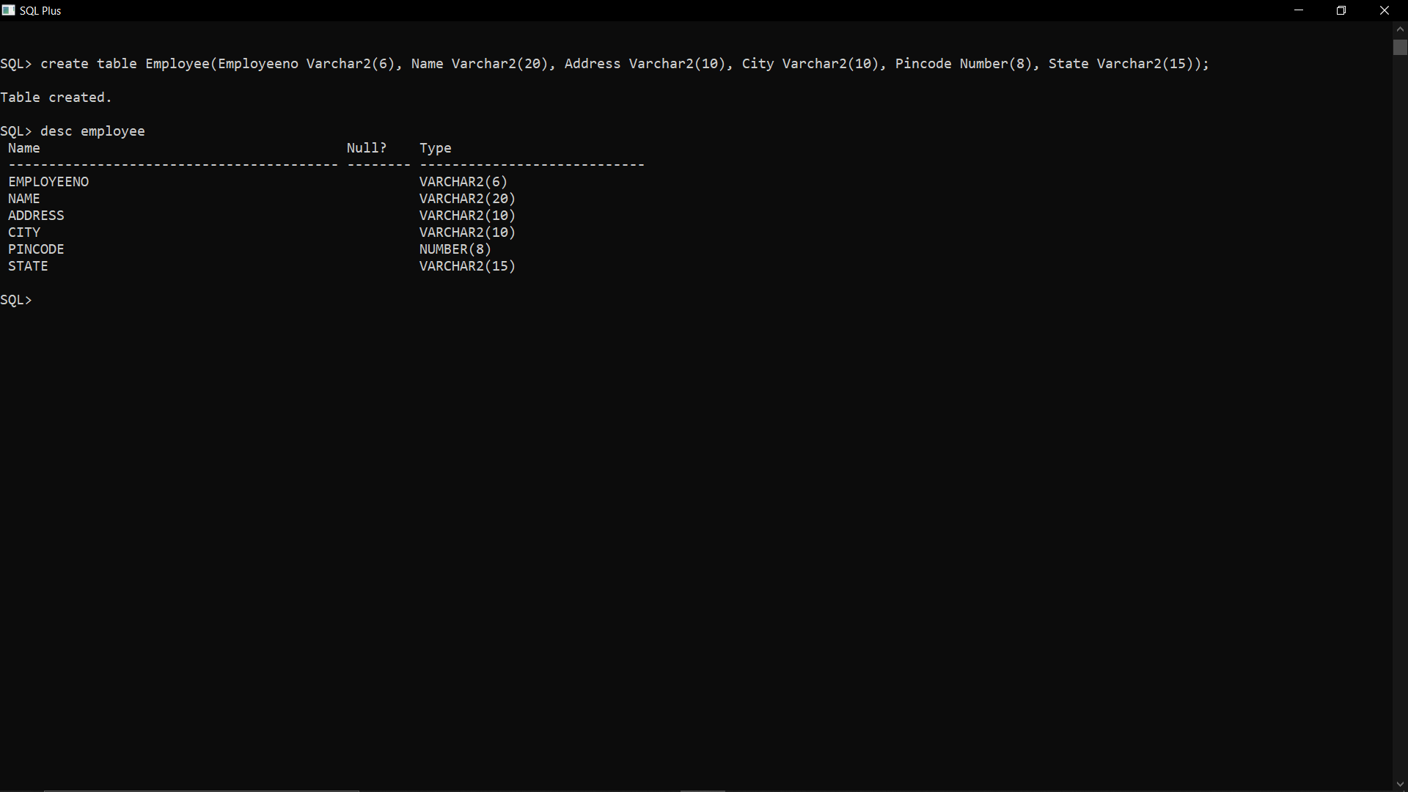

2. Insert the following data into the table

Employeeno Name Address City Pincode State

E00001 Bobby B/16, Butterfly Garden Chennai 400125 Tamilnadu

E00002 Jaya 444, Juhu Mumbai 890012 Maharashtra

E00003 Vasavi 58K,Tilak Nagar Banagalore 988233 Karnataka

E00004 Sanjay 89G, North Street Almora 895623 Uttrakhand

E00005 Sarita D/57, Rose Garden Chennai 400125 tamilnadu

E00006 Divya 897, Aanand Bihar Mumbai 890012 Maharashtra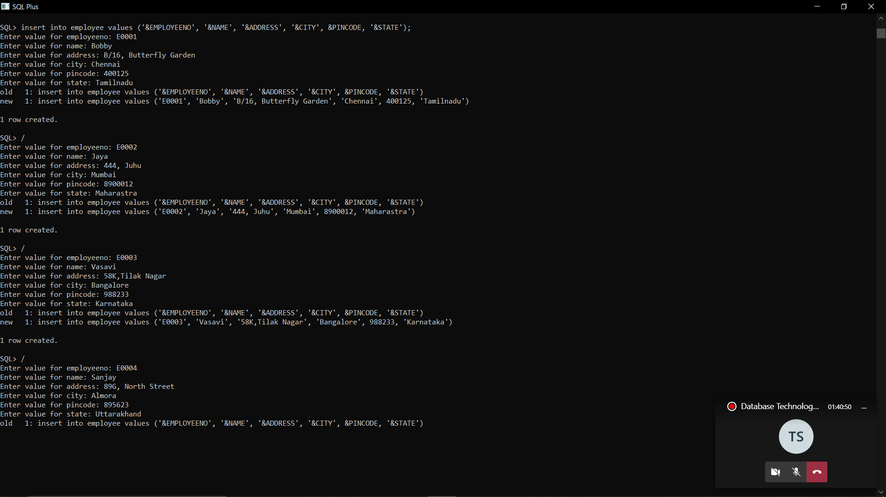

3. Retrieving records from a table

(a) Find out the names of all employees.

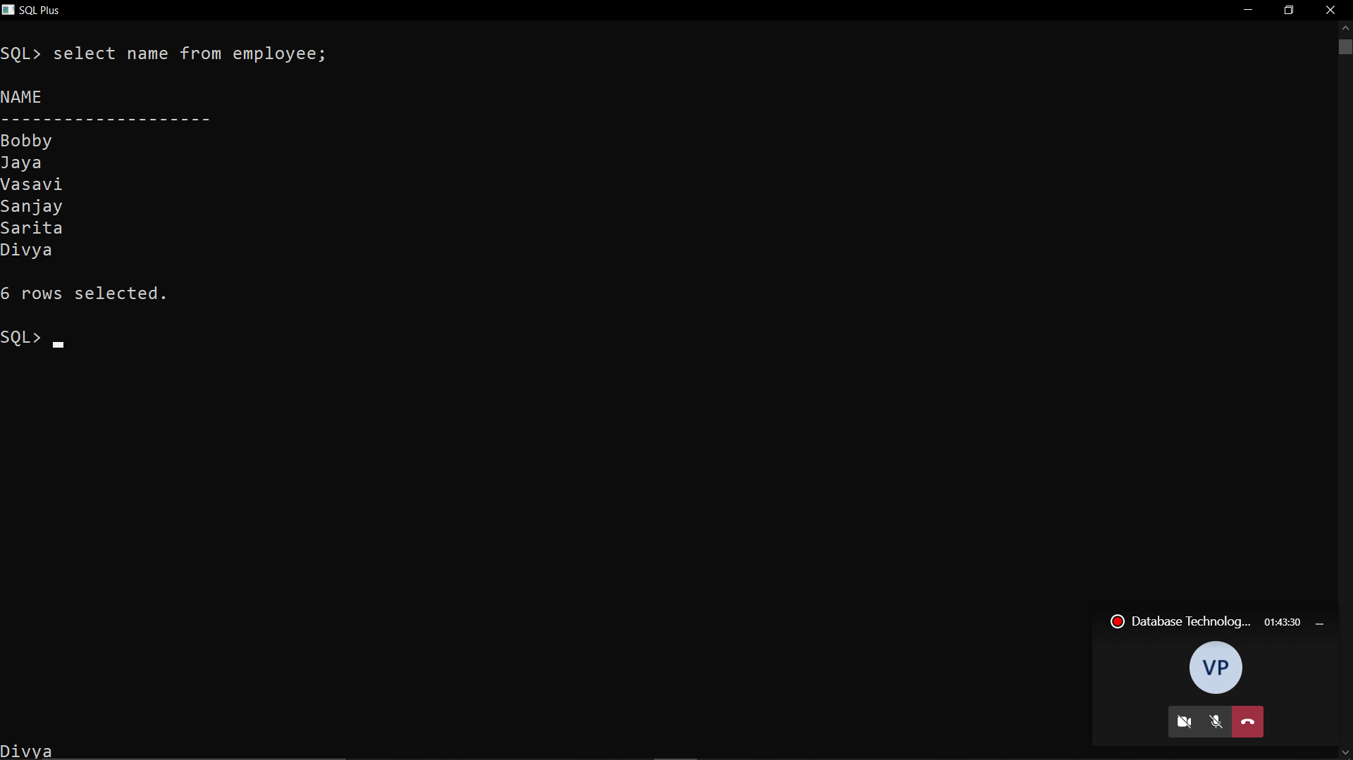

(b) Retrieve the entire contents of the employee table.

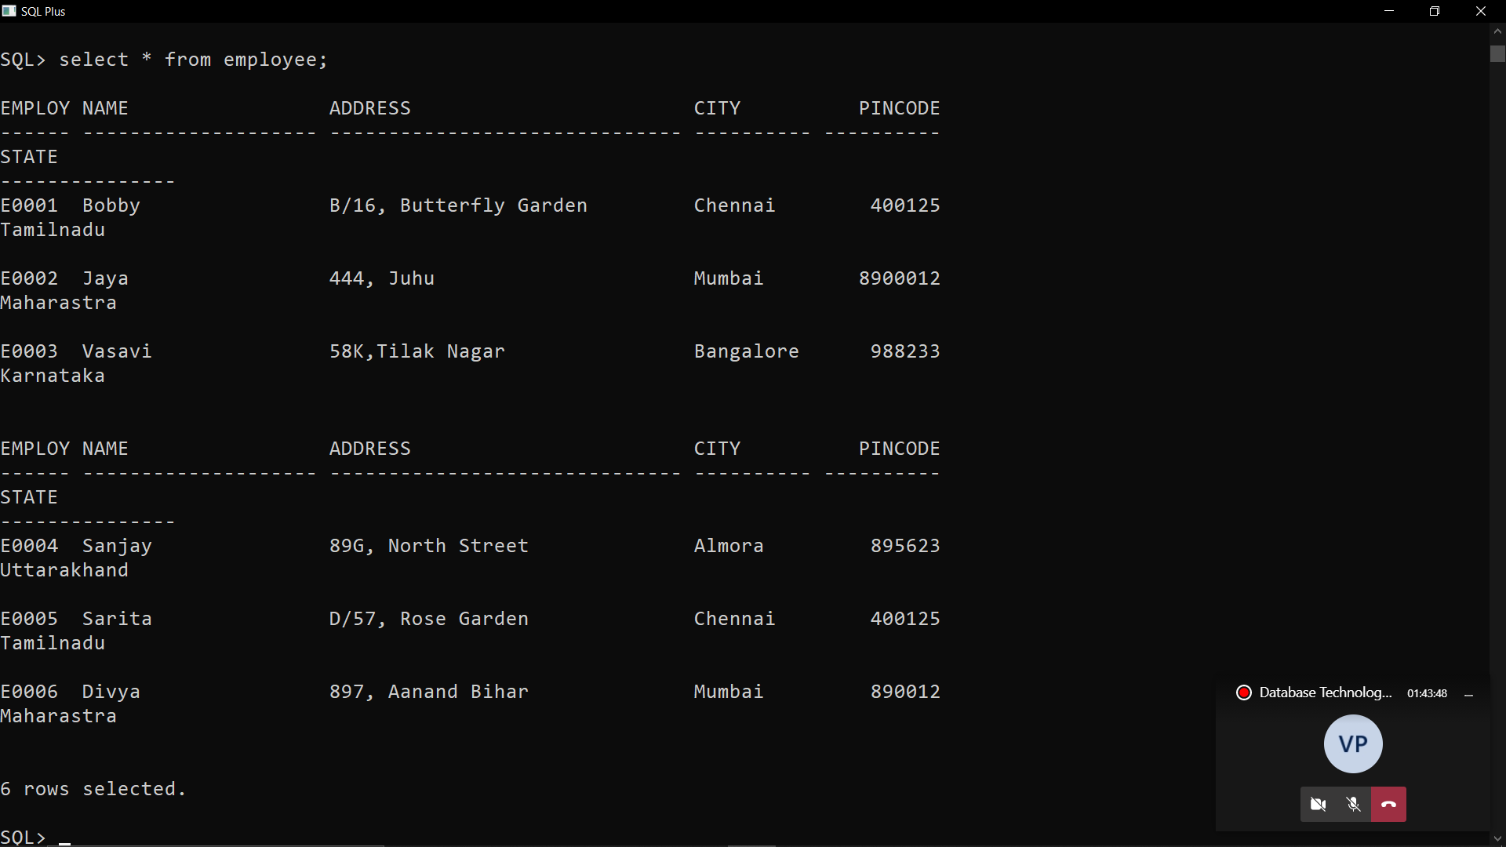

(c) List all the employees who are residing at Chennai.

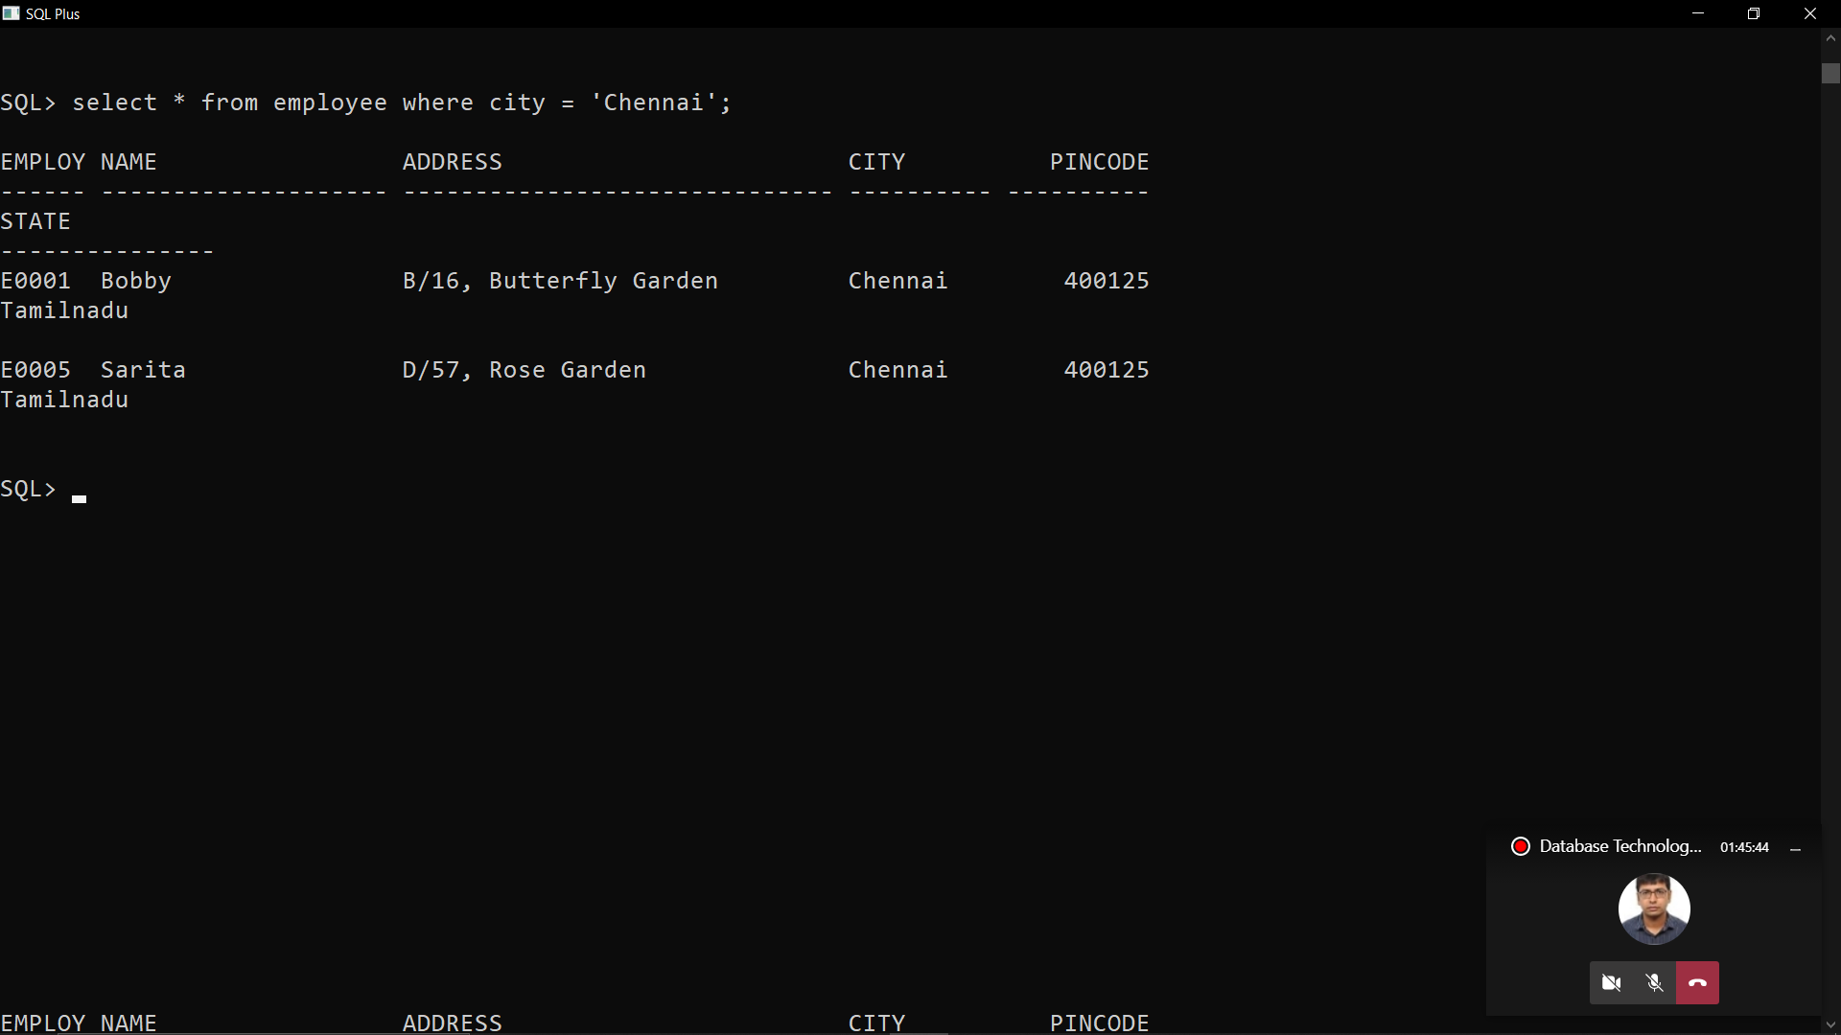

(d) Retrieve the list of address, city and state of all the employees.

SELECT ADDRESS, CITY, STATE FROM EMPLOYEE;

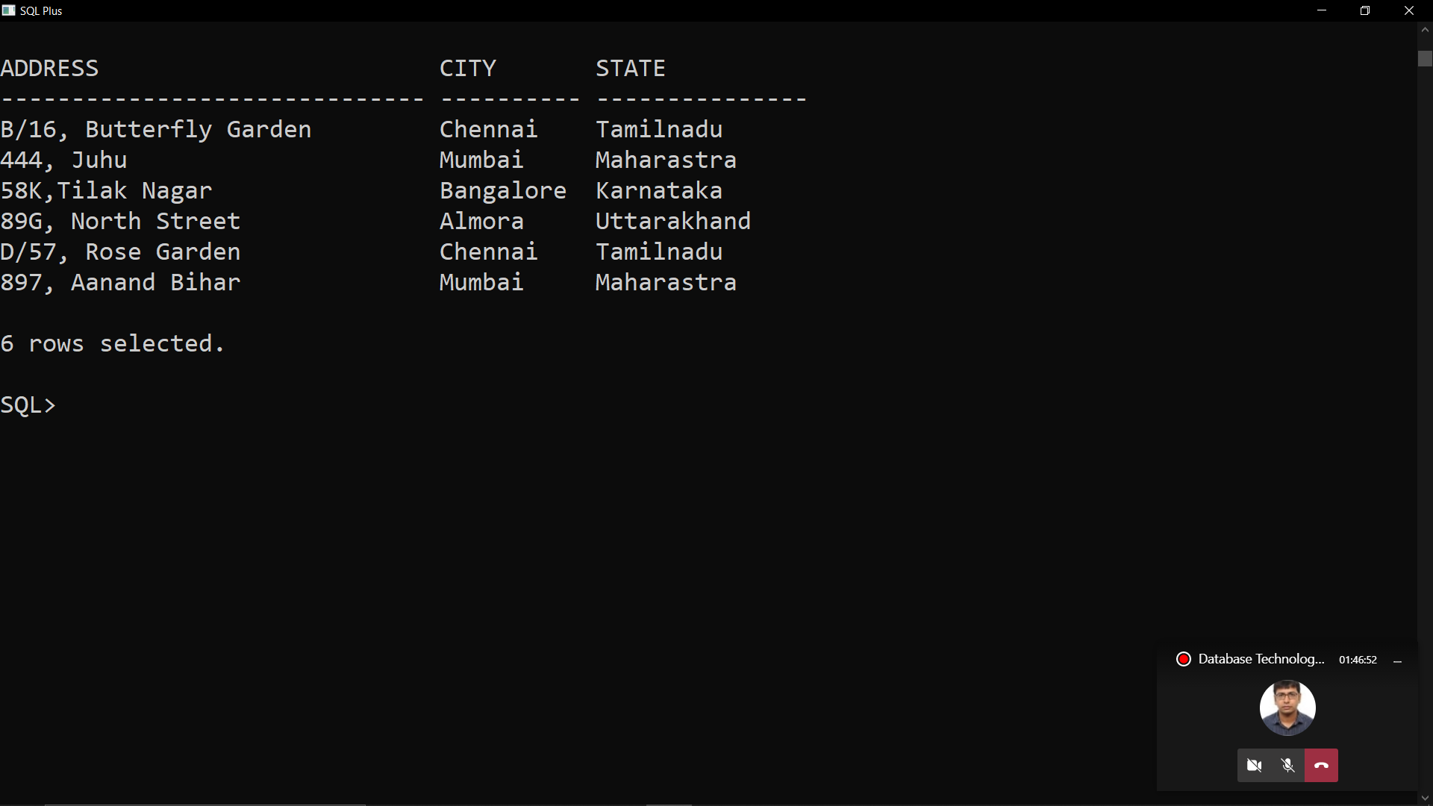

4. Updating records in a table

(a) Change the state of ‘Divya’ ‘Maharashtra’ to ‘Kerala’.

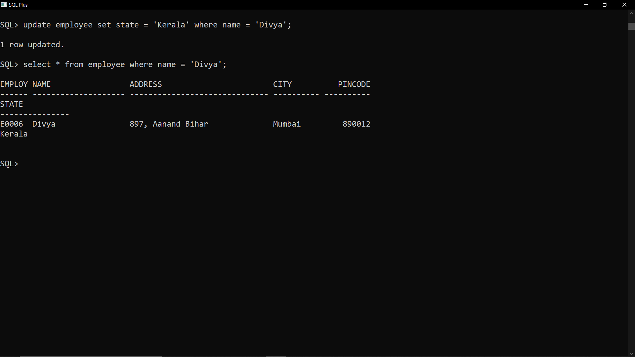

(b) Change the city of employeeno ‘E00002’ to ‘Chennai’.

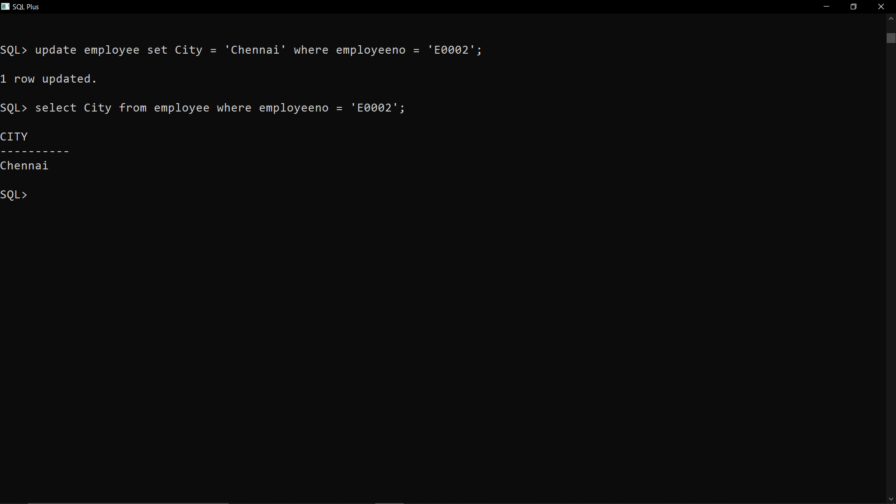

5. Deleting records in a table

(a) Delete from employee where the column city holds the value ‘Almora’.

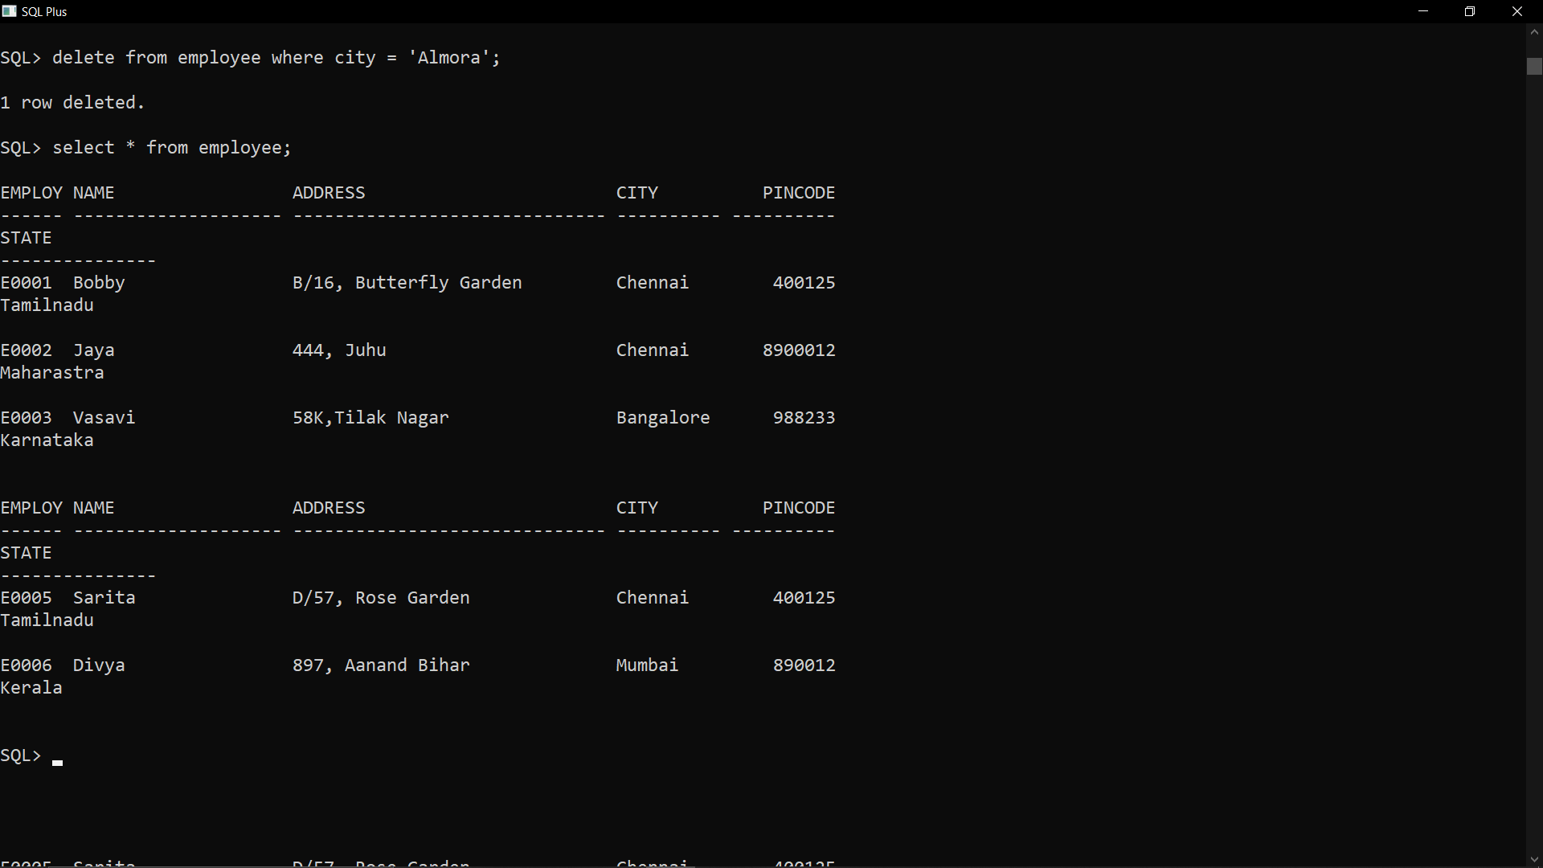

(b) Delete all employees from employee table where employeeno is equal to E00005.

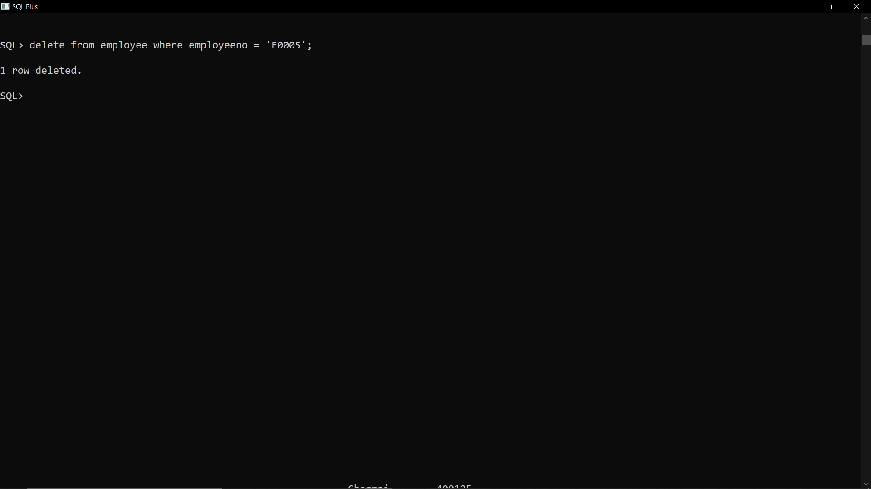

6. Altering the table structure

(a) Add a column call phonenumber of data type number10 to the employee.

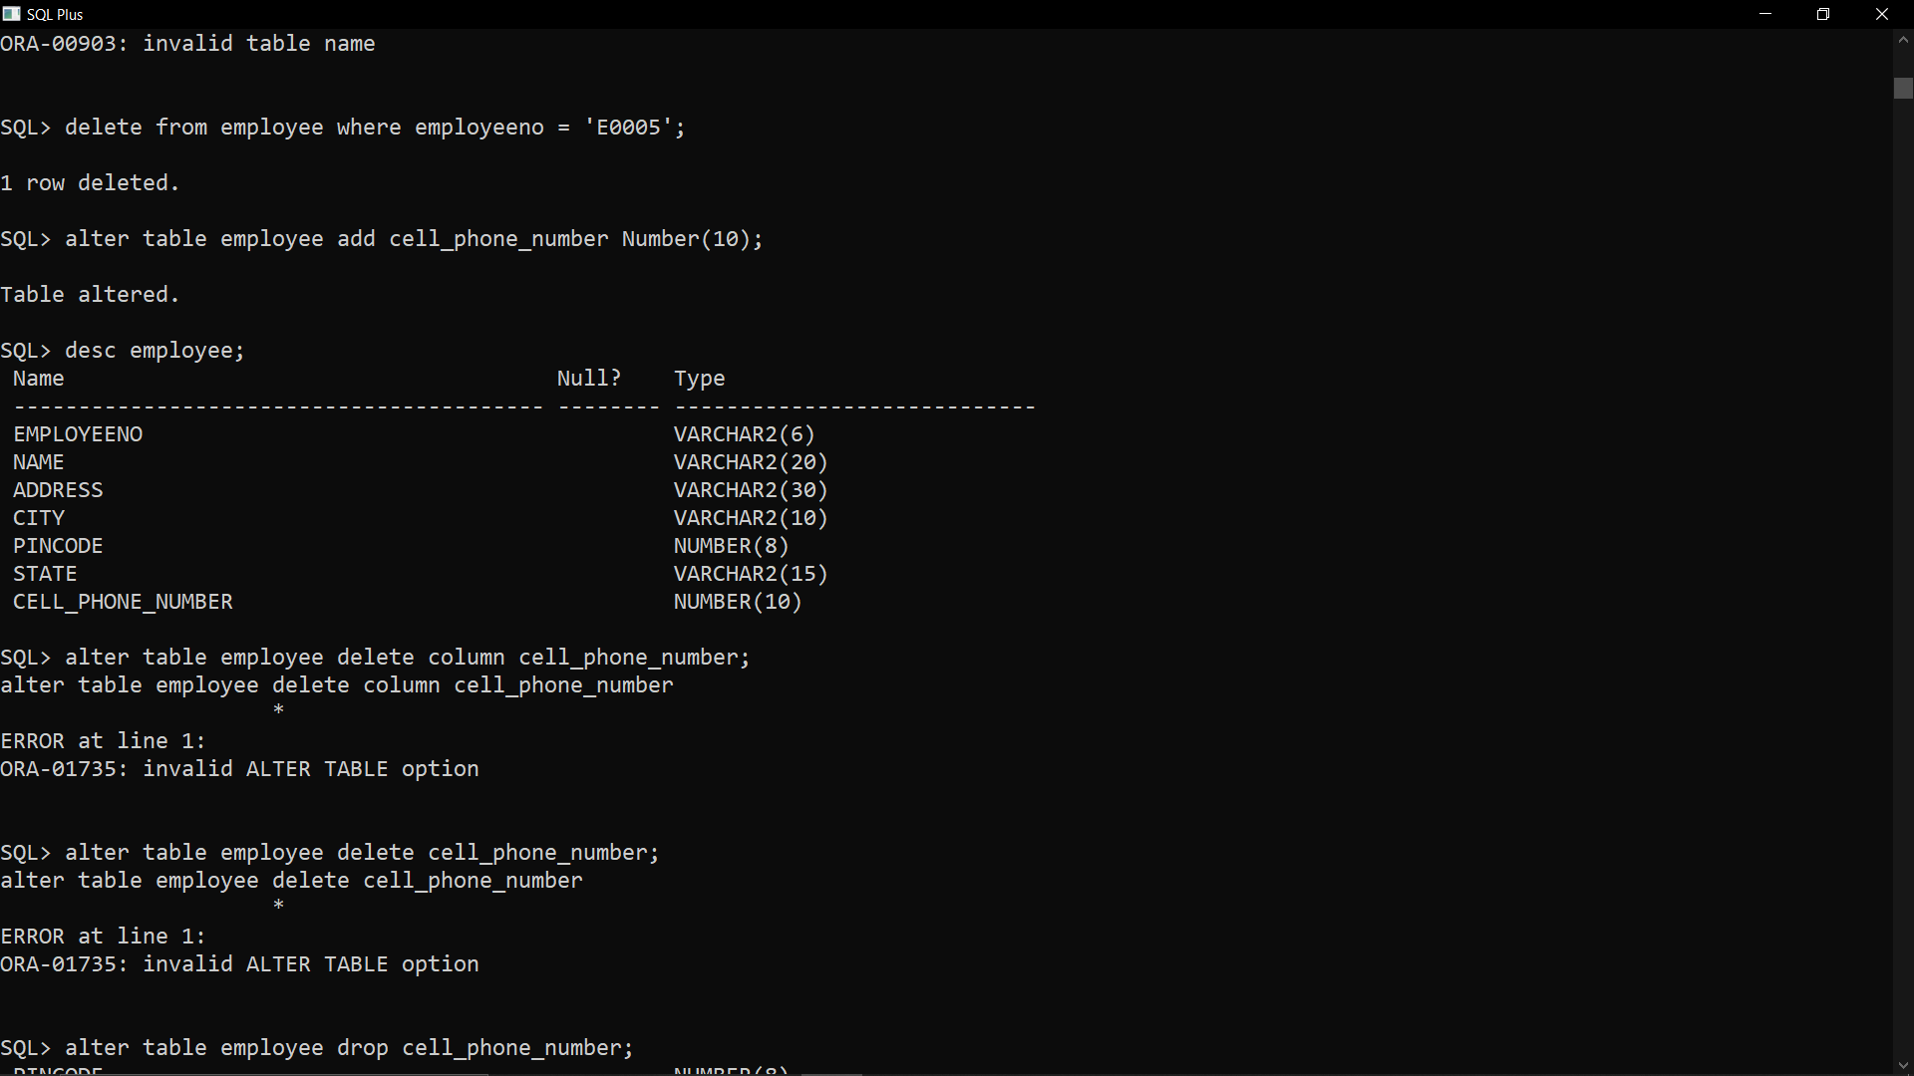

(b) Change the size of city column in employee to 13.

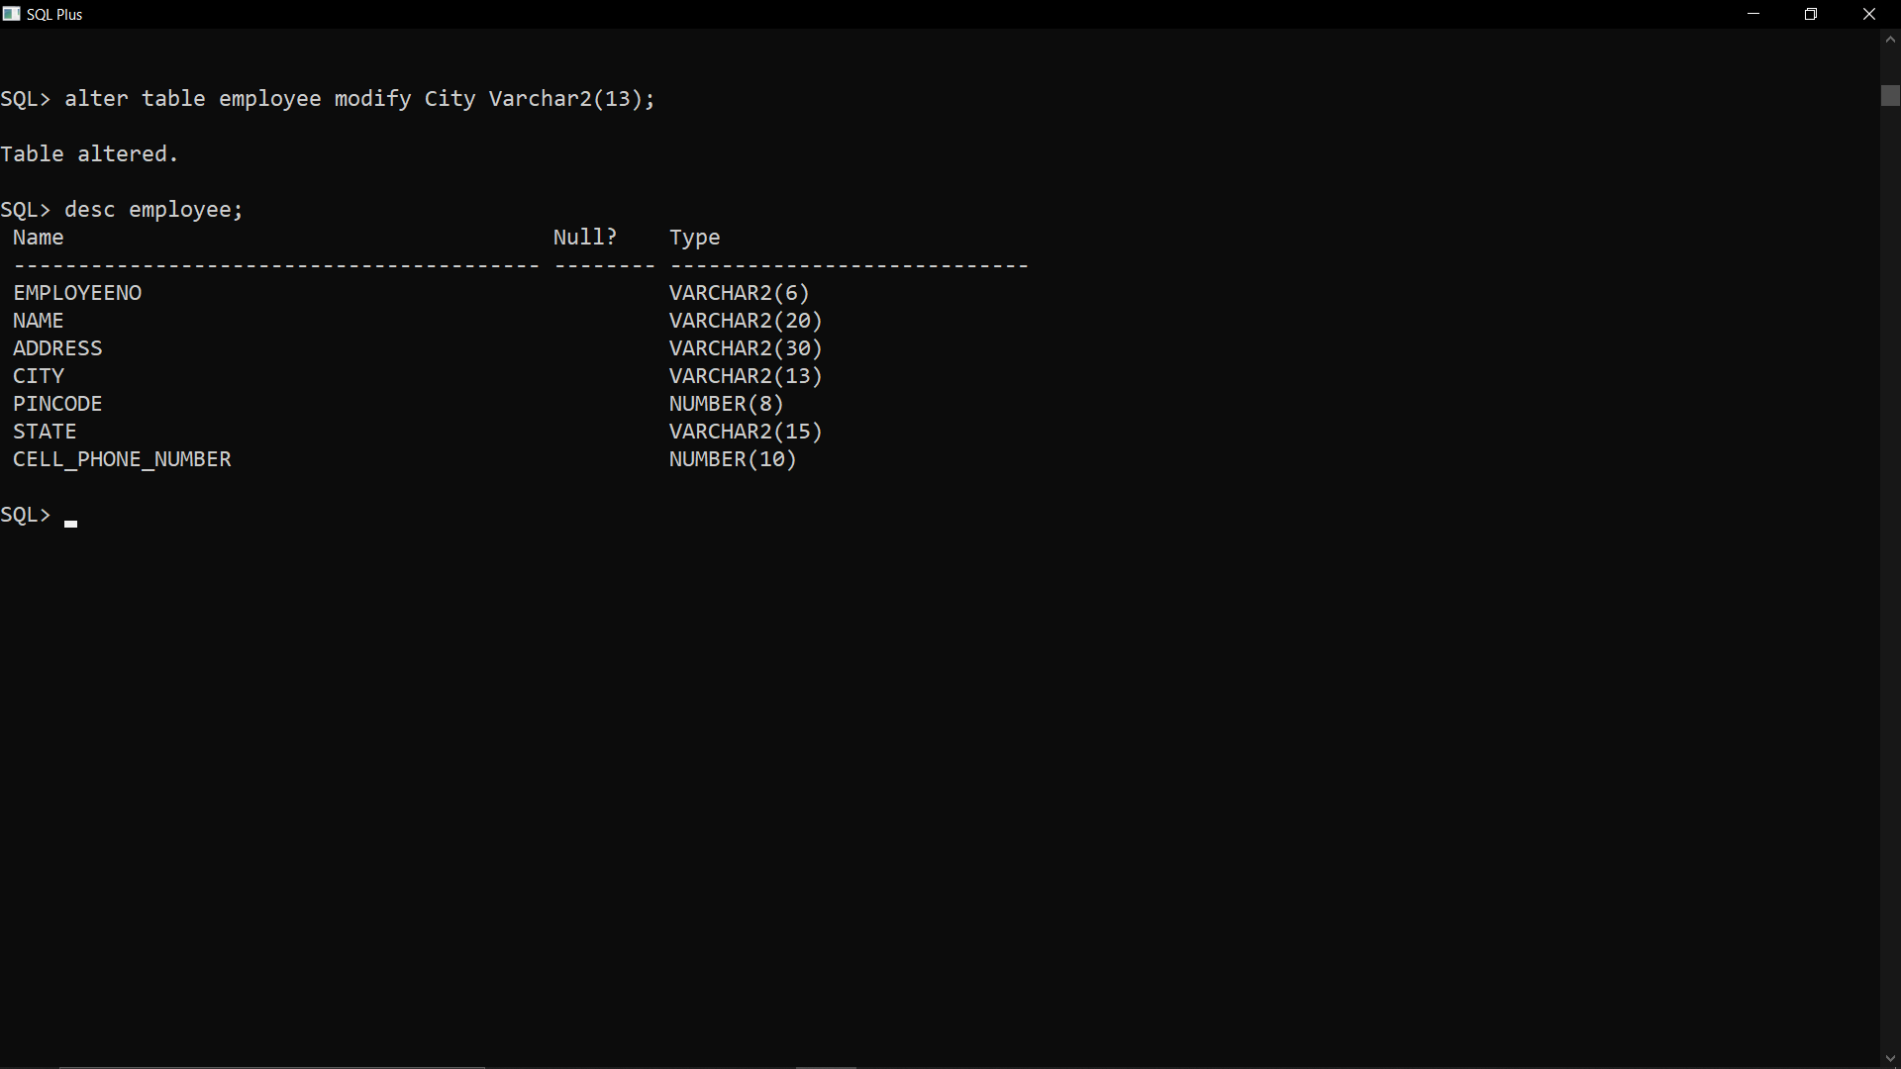

(c) Change the name of the column phonenumber to contactnumber in employee.

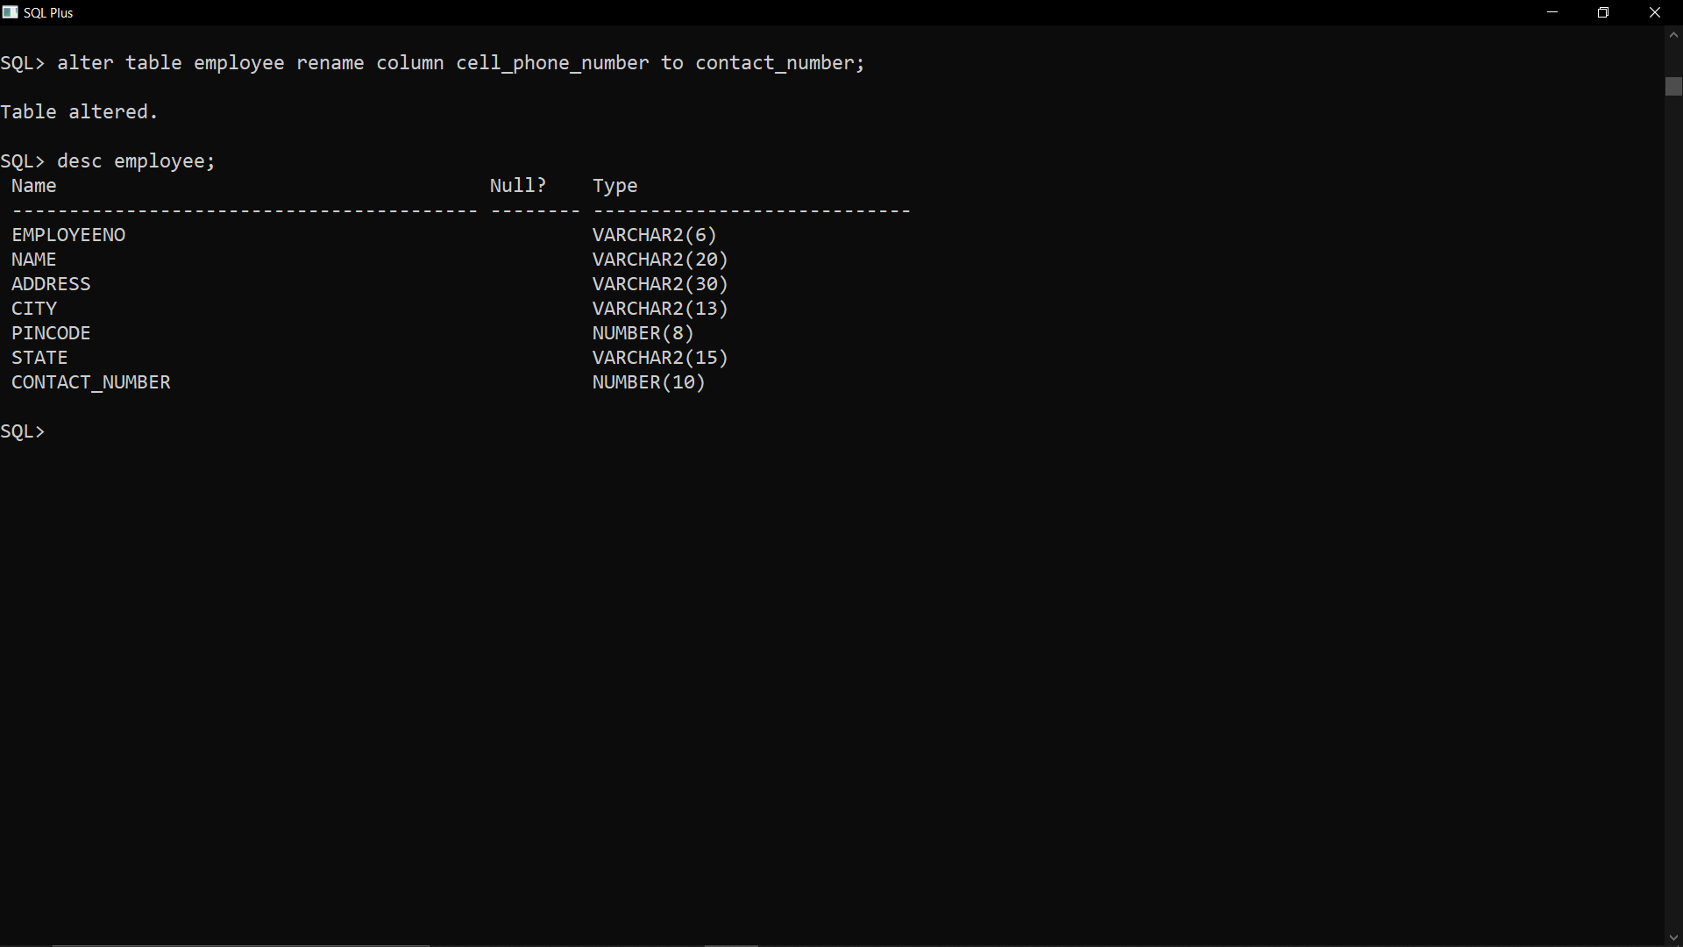

(d) Drop the column pincodes.

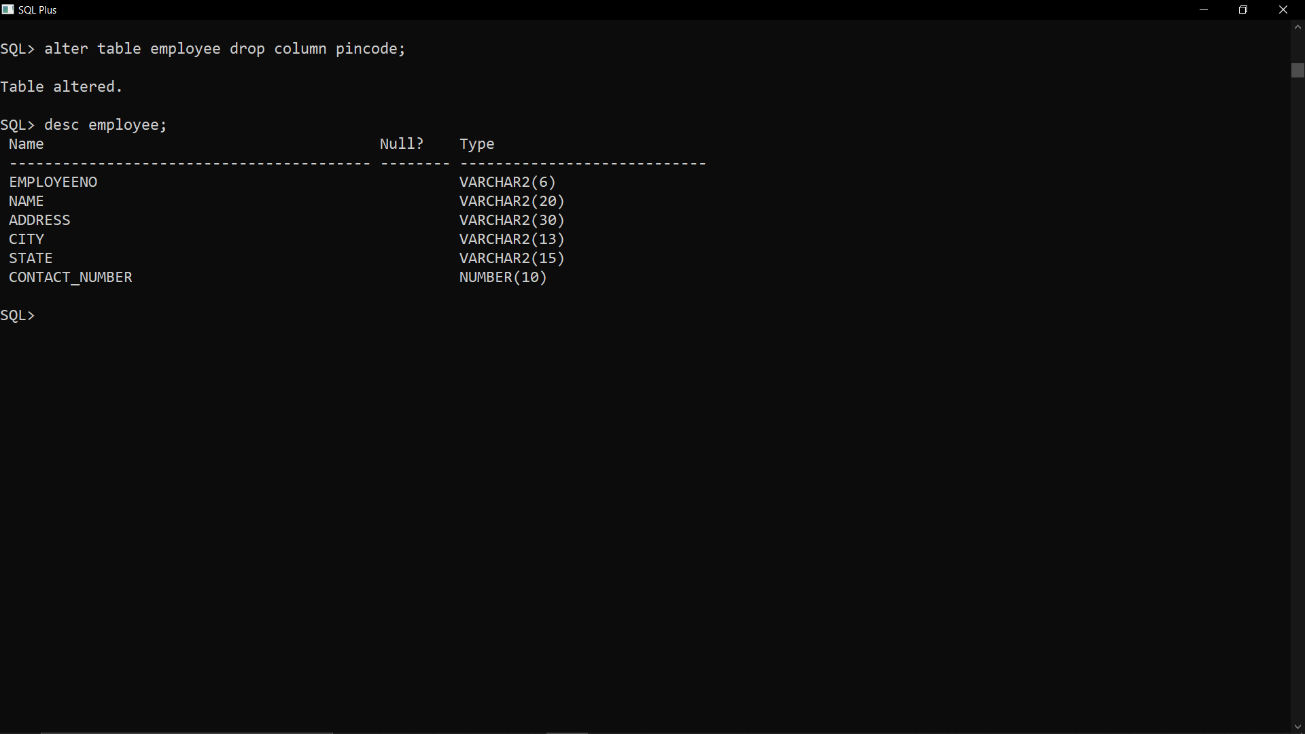

(e) Drop the table employee along with its data.

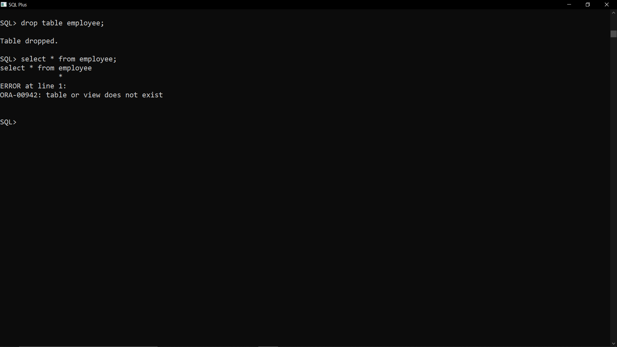

**Exercise – 2**

**WEEK_1**

Train(trainNumber, name, source, destination, start_time, reach_time, traveltime, distance, class, days, type)

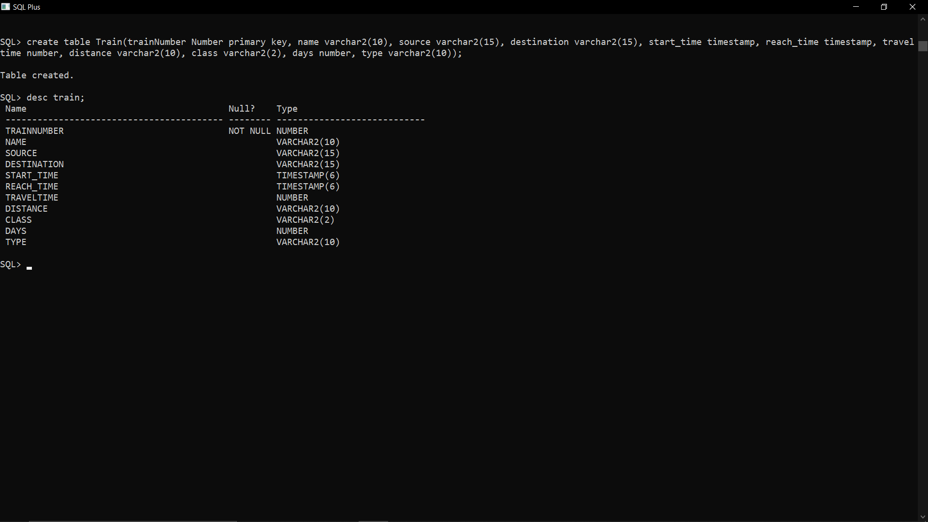

Ticket(PNRNo, Transactionid, from_station, to_station, date_of_journey, class, date_of_booking, total_ticket_fare, trainNumber)

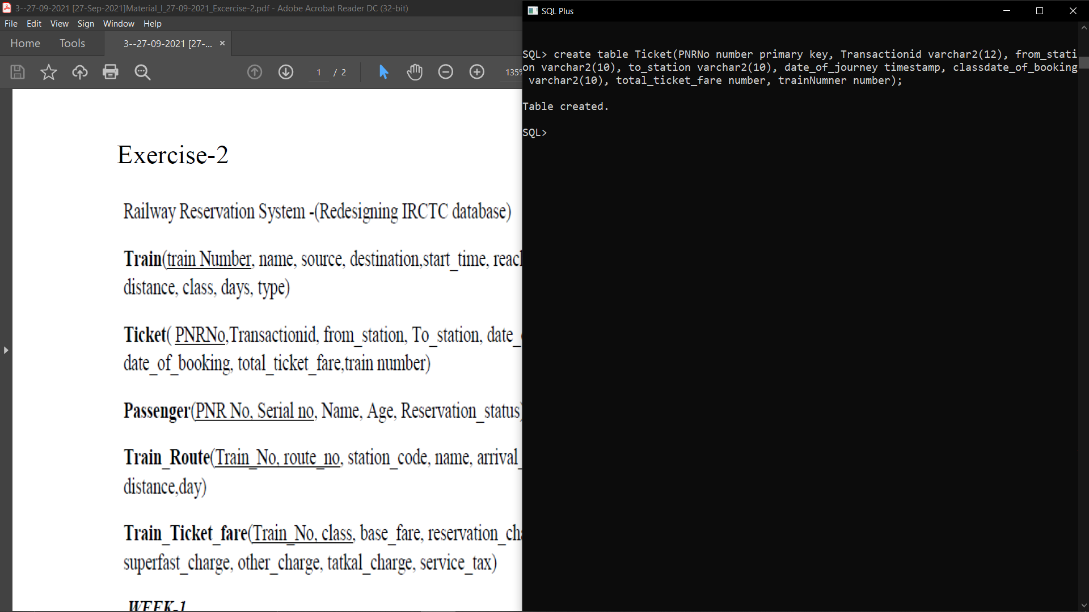

Passenger(PNrNo, serialNo, Name, Age, Reservation_status)

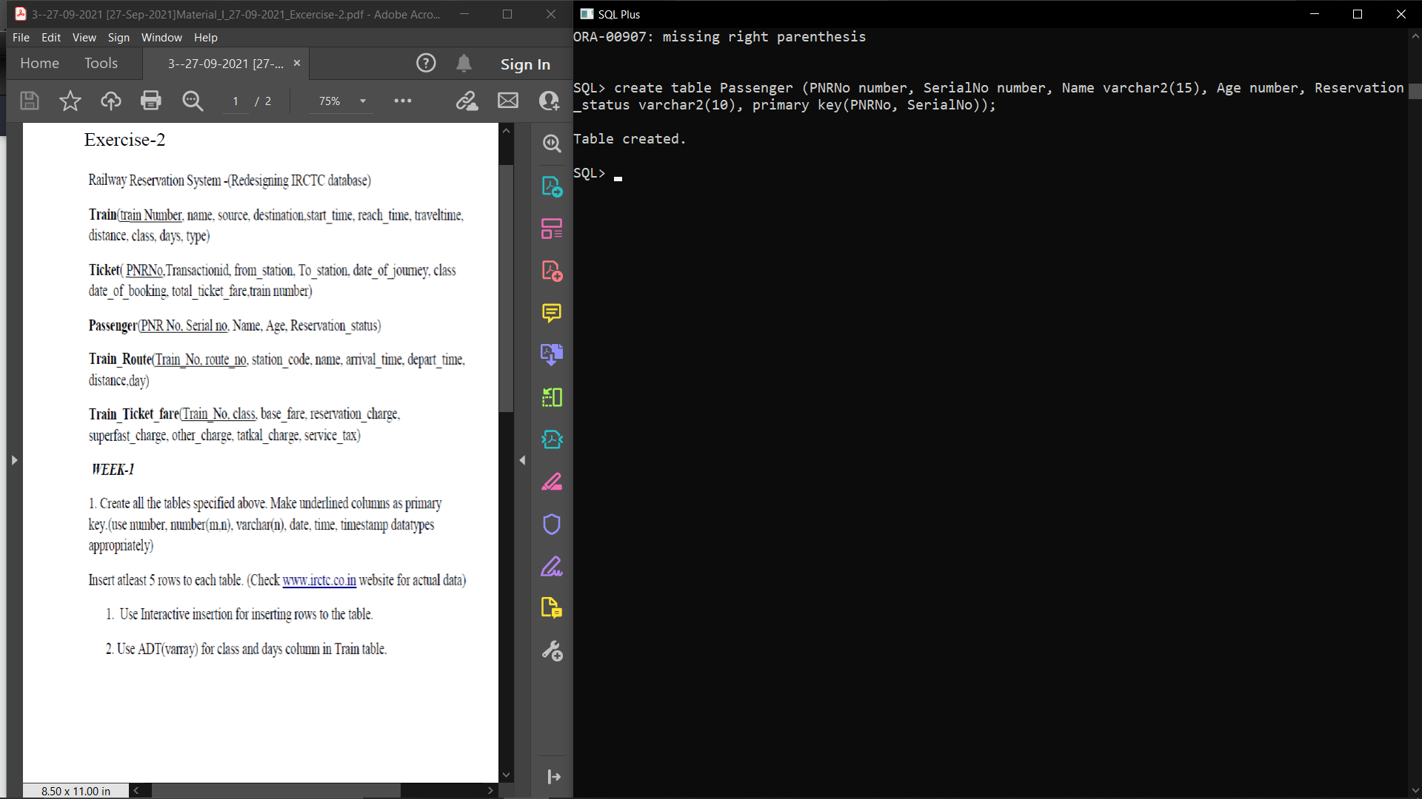

Train_Route(Train_No, route_no, station_code, name, arrival_time, depart_time)

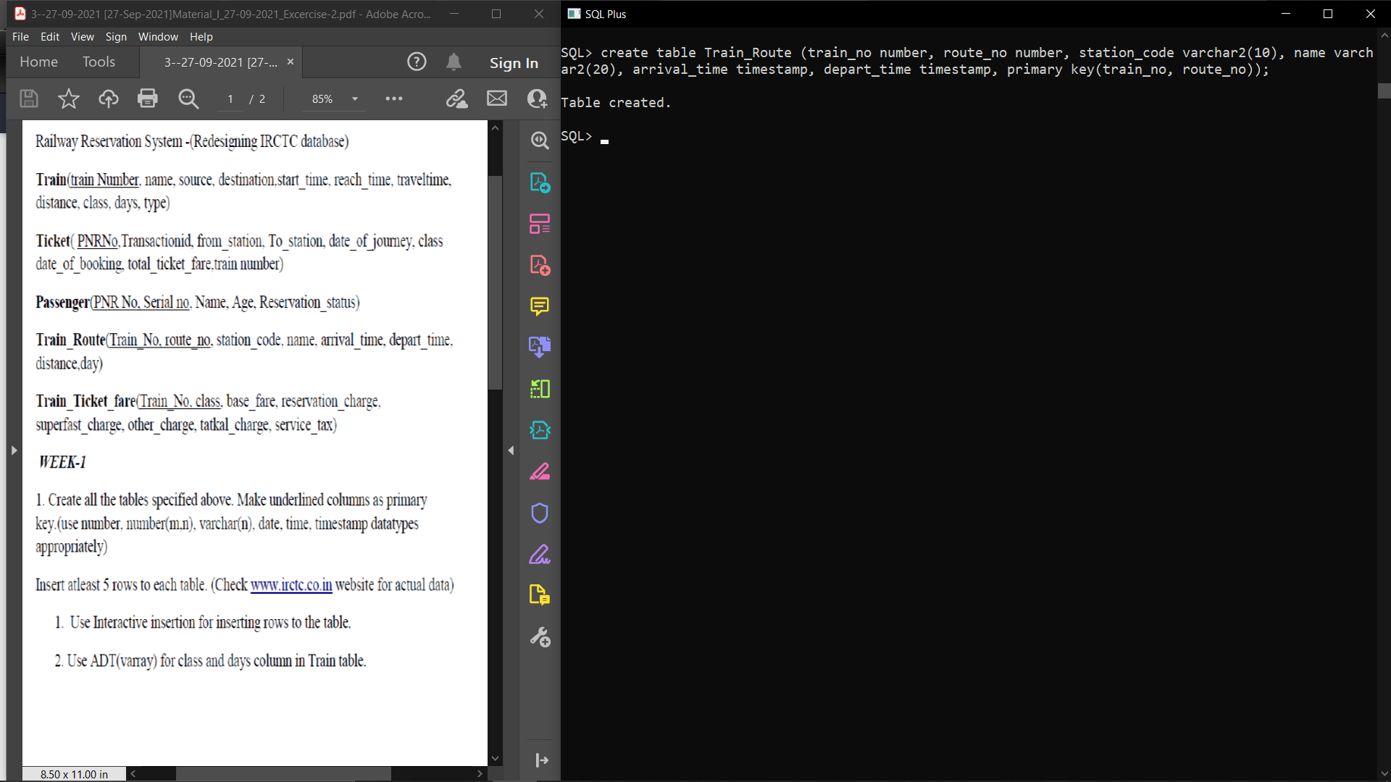

Train_Ticket_fare(Train_no, class, base_fare, reservation_charge, superfast_charge, other_charge, tatkal_charge, service_tax)

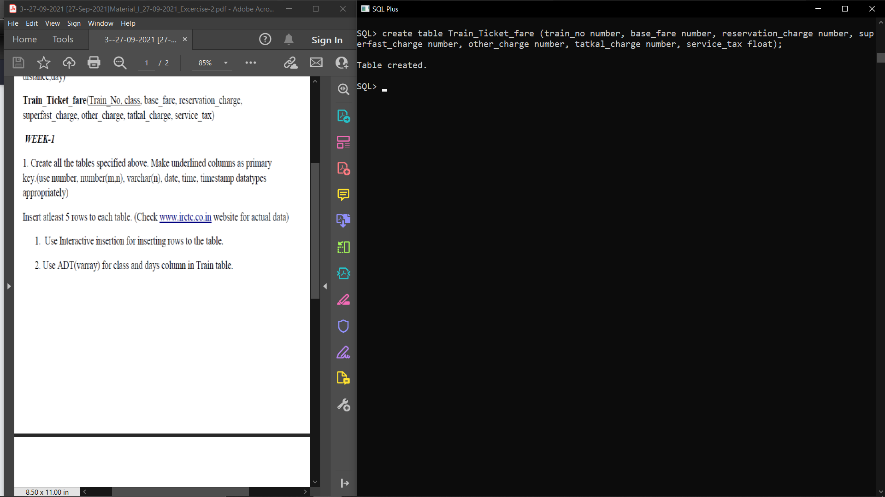

Inserting data intercatively into TRAIN table (command repeated 5 times with different data):  
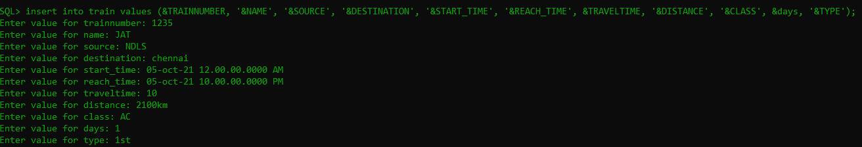

Inserting data intercatively into TICKET table (command repeated 5 times with different data):

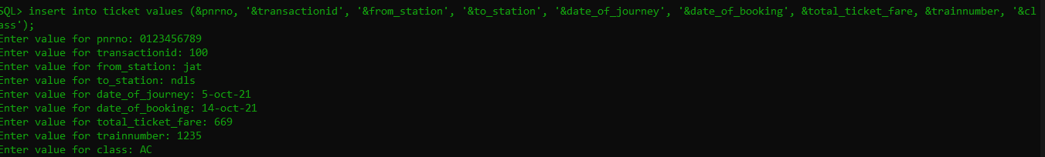

Interactively inserting data into PASSENGER table: fare (command repeated 5 times with different data):

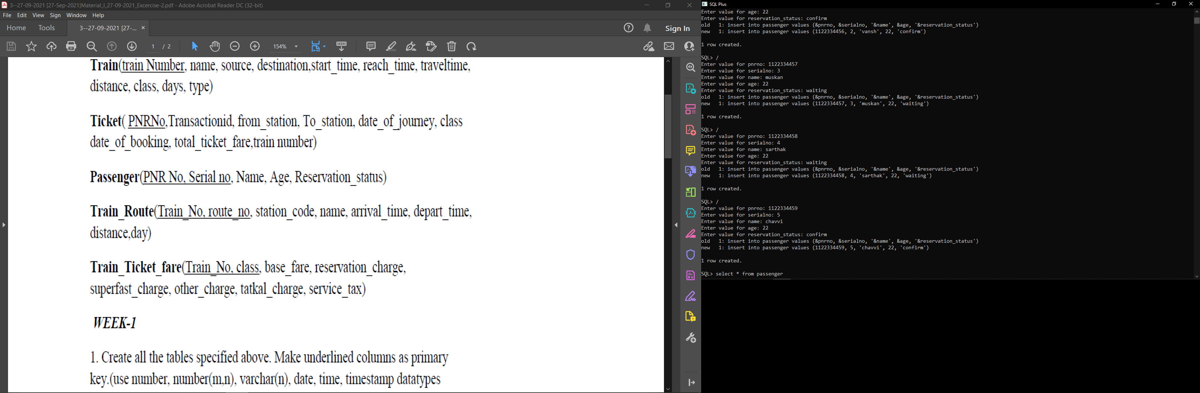

Inserting data interactively into TRAIN_ROUTE table(command repeated 5 times with diff data):

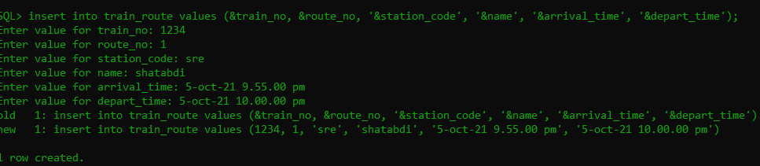

Inserting data interactively into train_ticket_fare (command repeated 5 times with different data):

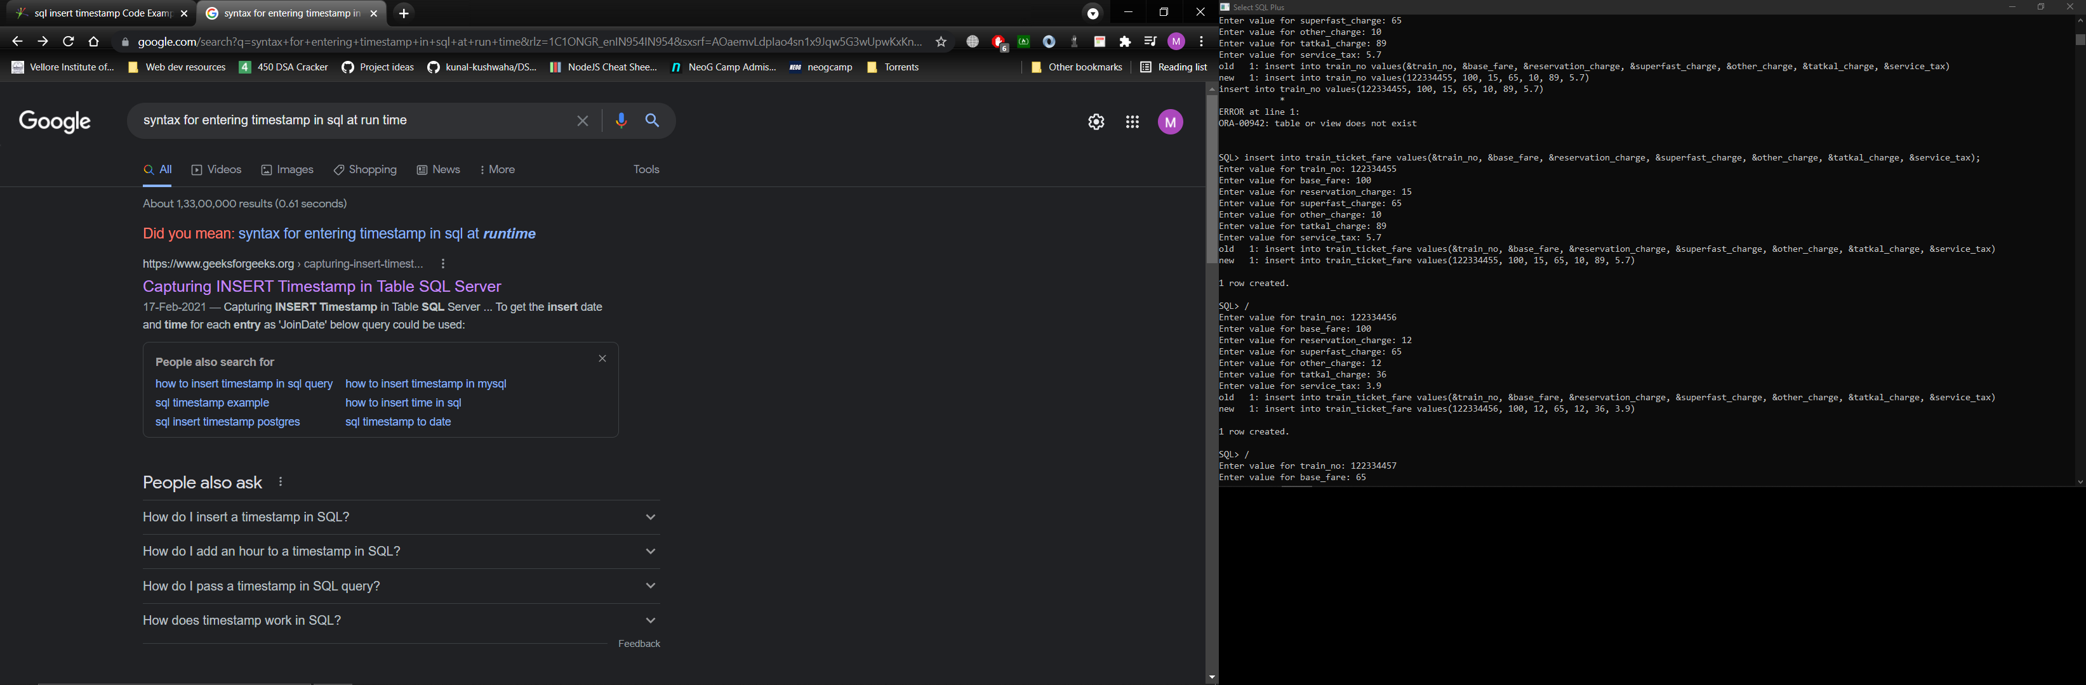

Use ADT(vararray) for class and days column in Train table

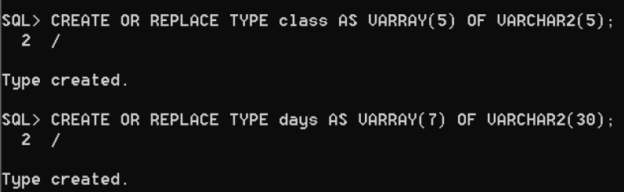  
week 2: use simple DDL/DML queries to.,

1.remove all the rows from passenger table permanently

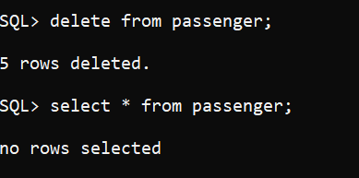

2.Change the name of the passenger table to passenger details.

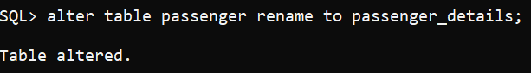

3.List all the trains details.

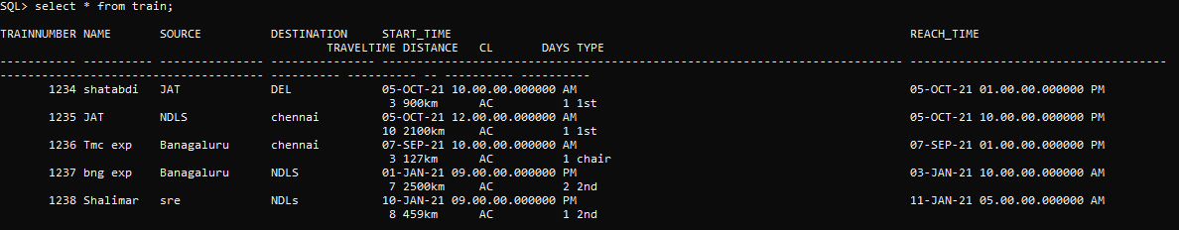

4. List all passenger details;

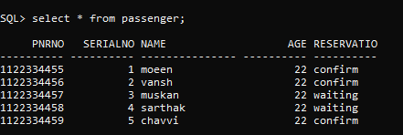

5. Give a list of trains in ascending order of trainno.

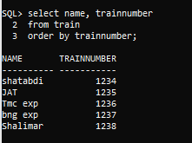

6. List the senior citizen passengers’ details.

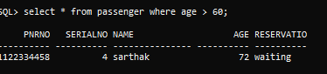

7.List the station names where the code starts with ‘M’

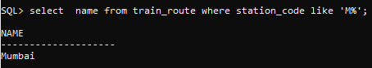

8. List the trains details within a range of trainno.

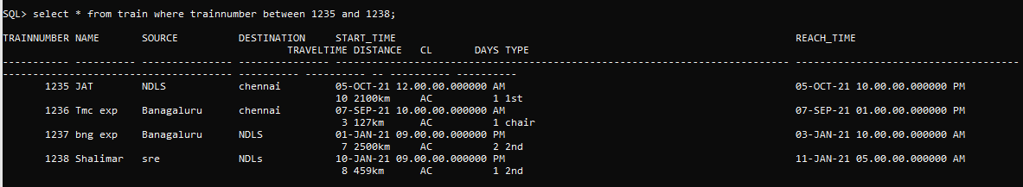

9.Change the superfast charge value in train fare as 0, if it is null.



10.list the passenger names whose ticket is not confirmed

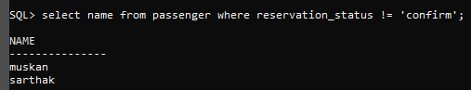

11. List the base fare of all AC coaches available in each train.

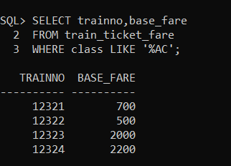

12.Find the ticket details where transaction id is 20000350.



1. Use Interactive updation for updating the serialno for particrtlar PNR NO.

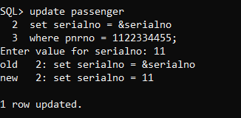

2. Find the train names that are from Chennai to Mumbai, but do not have source or destination in its name

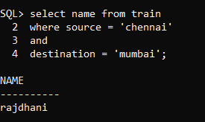

3.find train details that are on Thursday.

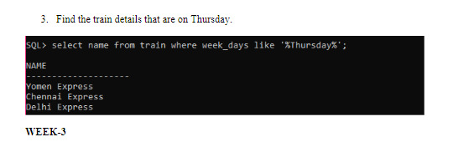

WEEK 3:

1. Add a suitable constraint in train table to always have trainnumber in range 10001 to 9999.

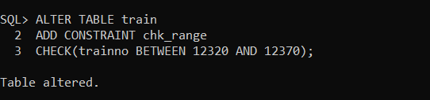

1. Add a suitable constraint for column of station_name, so that it doesn’t take duplicates.

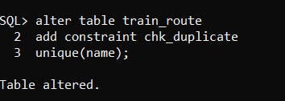

1. Add a suitable constraint for the class column that it should take values only as 1AC, 2AC, 3AC, SLEEPER.

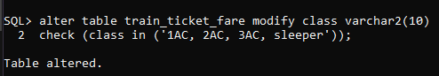

**PART A:**

Use SET operators

1. Find the train numbers for which reservation have not yet been made

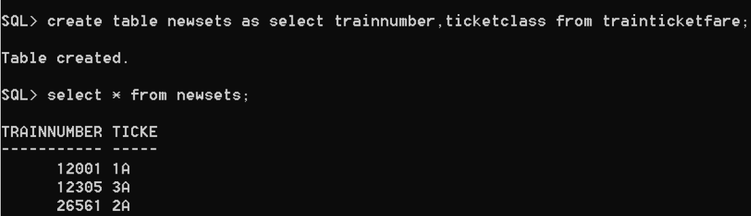

1. Find the train names that do not have a first AC class coach.

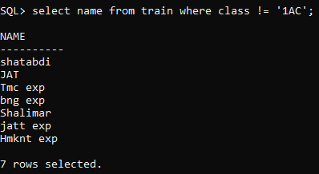

1. Print all the PNR numbers available in the database

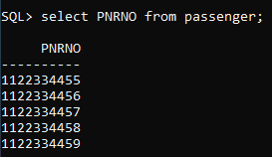

1. Find passengers names who have booked to ‘PUNE’

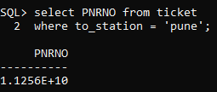

**Use nested query (in operators)**

1. Find the train names that stop in ‘katpadi’

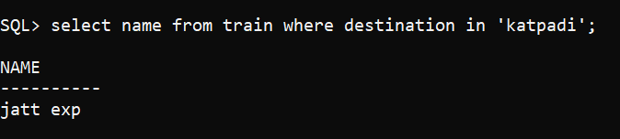

1. Find the train names that are superfast and service tax is zero.

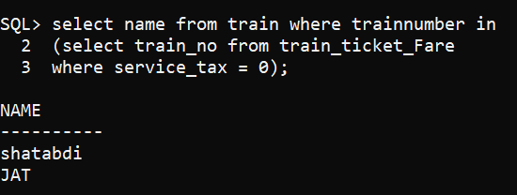

1. Find the passenger’s name who have booked for the train that starts from ‘Chennai’

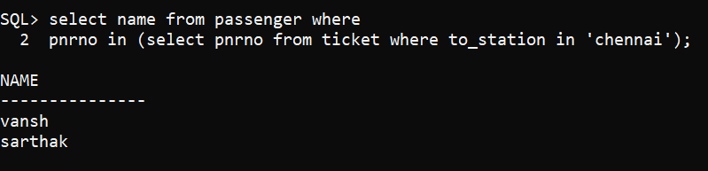

1. Find the trains names that have all the AC coaches and base fare < 3000;

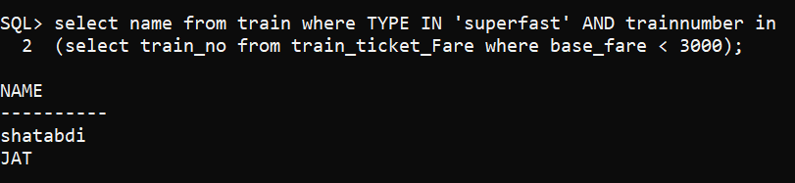

Use Join Query

1. Find the train names that stop in ‘katpadi’

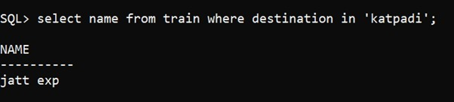

1. Find the train names that are superfast and service tax is zero.

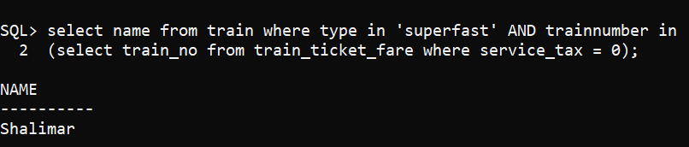

1. Find the passenger’s name and train name who have booked for the train that starts from ‘Chennai’

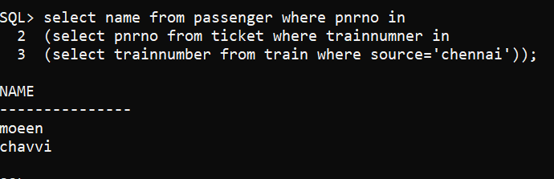

1. Display the train names of each type of class and the total fare for each type of class.

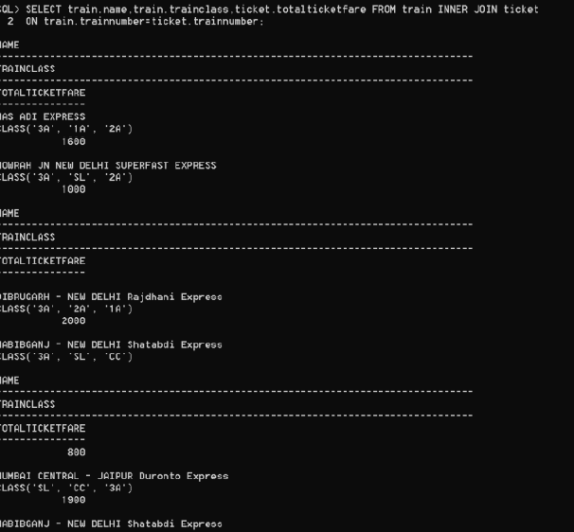

1. Display all the train details and ticket details (if booked any)

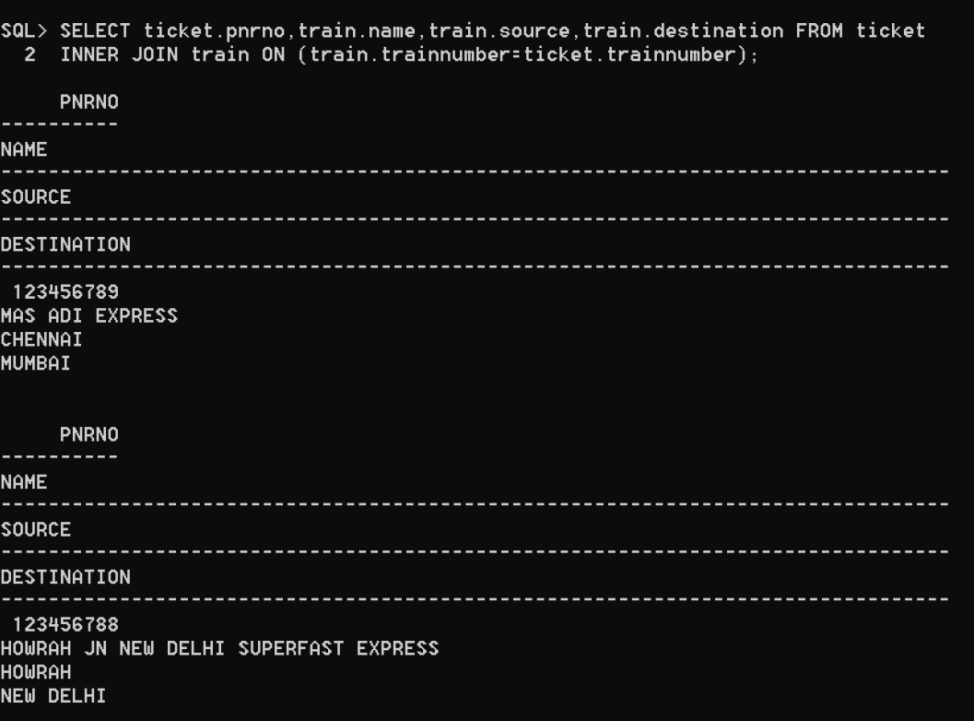

1. Create a sequence to provide values for the PNR no.

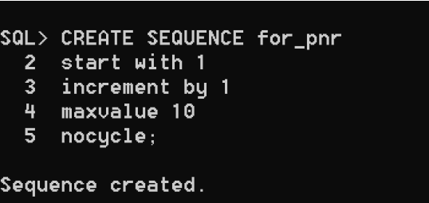

1. Write a query for full outer join using any of the tables above.

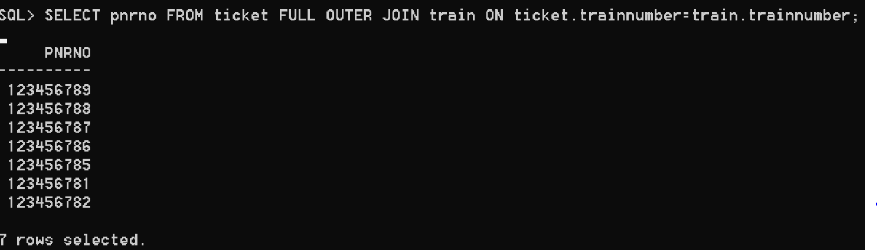

PART-B

Write Queries to.

Use corelated (and nested) queries

1. Find the train names for which ten tickets have been reserved.



1. Find the trains that have more than ten substations.

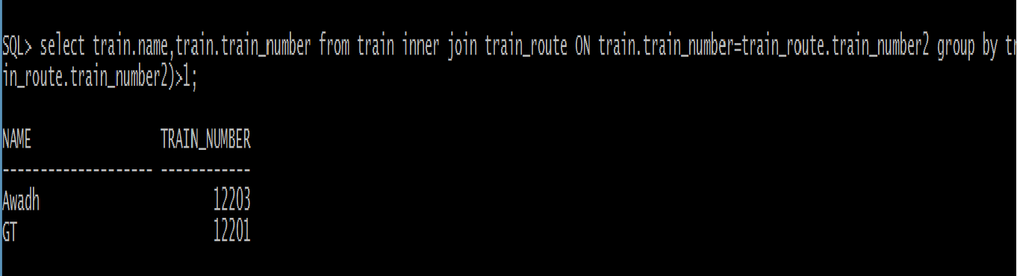

1. Find the passengers who do not pass through ‘Mettupalam’

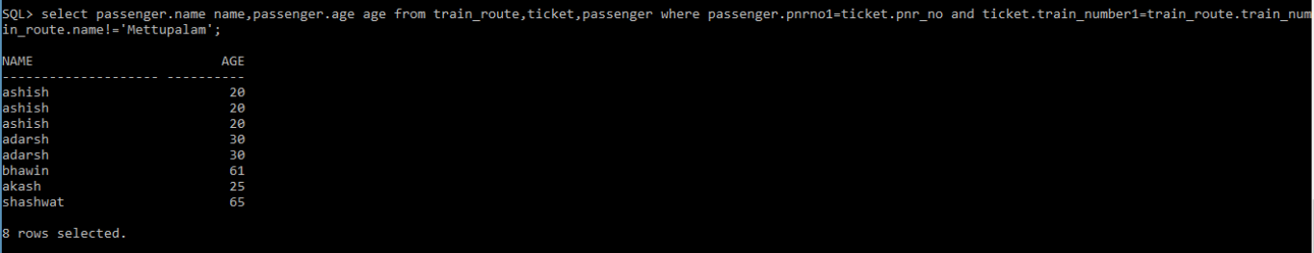

1. Find passengers who have booked for superfast trains.



Complex queries (use groupby/join/nested)

1. Take the start station code and end station code and display the train details

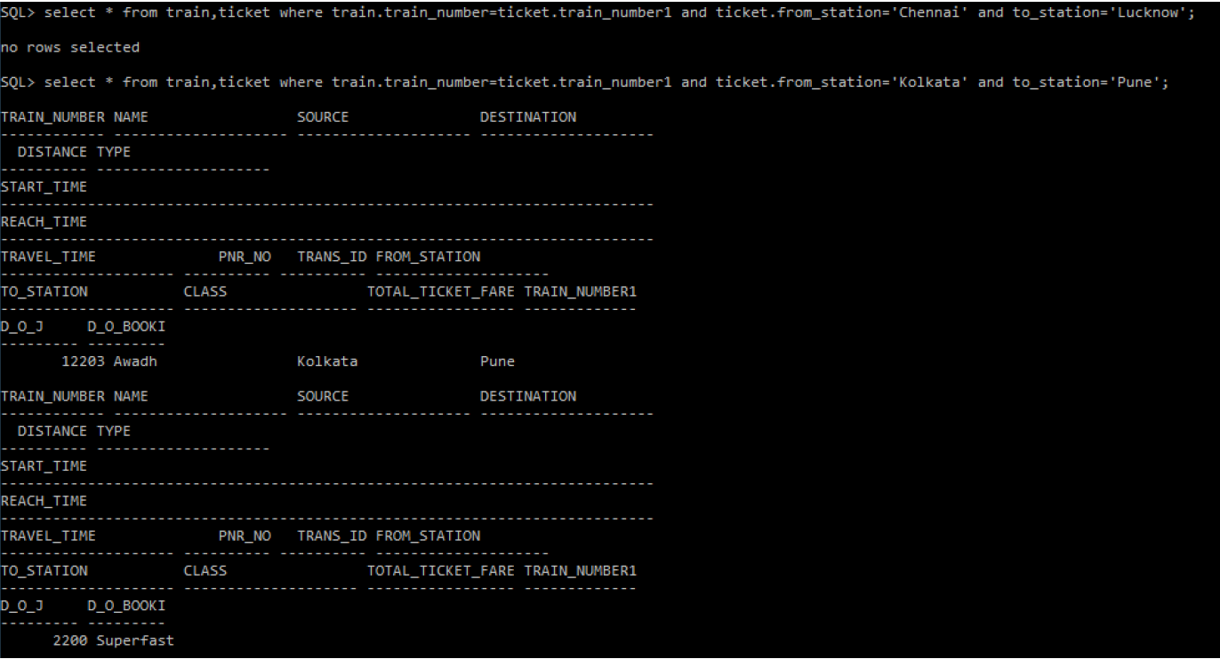

1. List the stations where all the types of train stop.

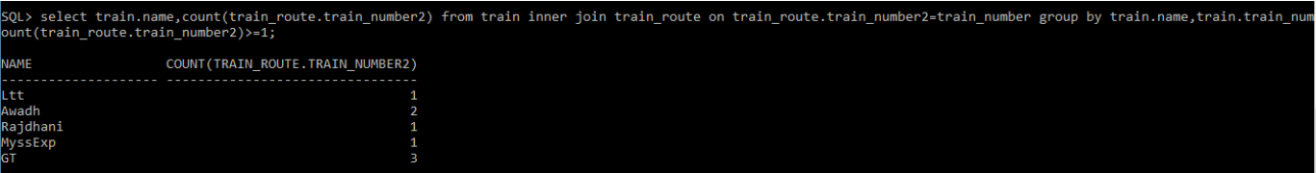

1. List the train names that has atleast four bookings.



1. Create a table cancelation history (insert values from ticket and passenger table)

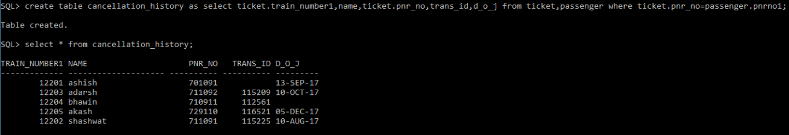

1. Create a table for all the train numbers and class available in train_ticket_fare with total seats.



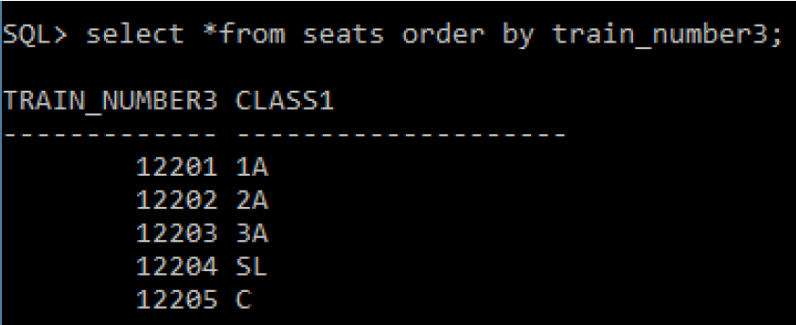

1. Find the station name that has highest number of trains stopping at

